Thesssssss
The Schuylkill Canal Revisited

The Schuylkill Canal correctly referred to as: “The Schuylkill Navigation Company” was first opened in July of 1824. Work began on the waterway shortly after it was chartered in 1815. This series of canals and slack water pools stretched 108 miles from Port Carbon in the north to the port of Philadelphia in the south. At that time the primary purpose was the economical transportation of anthracite from the rich coal regions in the north to the big city in the south.
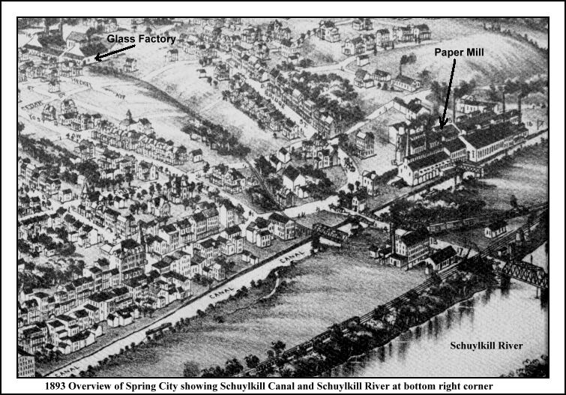
In this section of an 1893 overview map you can clearly see the path of the old canal as it passes through the town of Spring City. At the top right section on the map you can see the old paper mill. The mill was in the process of closing at this time and the property was actually leased to the Pennsylvania Shafting Company the following year. Passing by the mill the next structure in view is the canal bridge, close by to the present day Turkey Hill Market. The small iron bridge just below the canal bridge is that of the PRR railroad. The railroad siding snaked its way up to the Bennett Glass Works shown at the top left side of the map. As one follows the canal it continues on in back of the stores and houses on Main Street. There were numerous industries on South Main Street at this time. The next prominent industry at the bottom left (not shown on the map) would have been the Spring City Stove Works of Yeager & Hunter. The canal continues on past the industries on South Main Street and rejoins the river below Spring City at lock 59.

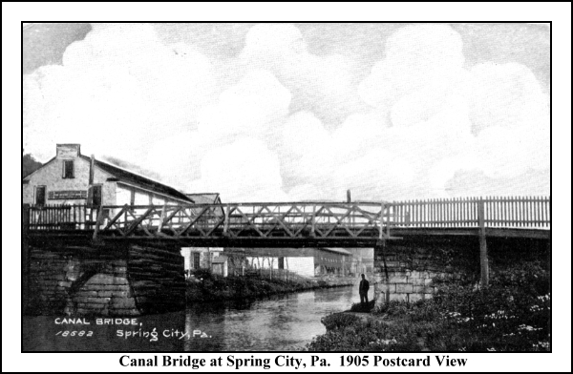
This highway of water gave rise to a multitude of development along its path. Stores sprang up at many of the locks and in some cases they were actually located in the lock keeper’s house. Villages and towns like Springville developed along the canal. James Rogers started the first store in Springville in 1835. In 1843 Rogers started the local Foundry. Just like his store, the business he started was on the canal. The Stove Foundry used the canal to bring in raw materials as well as shipping out the finished cast iron products. The most notable product at this time was the old nine-piece wood-burning stove. Please note that we do have one of these early Rogers’ stoves on display in our museum. Roger’s business employed 25 men and needless to say they were all local.

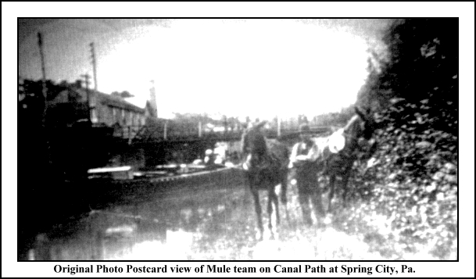
In the above view one can see the canal and canal bridge. The buildings in the back are part of the shafting works and the building at the far left is the Spring City newspaper building. Mules were often used to pull the canal boat. Most crews consisted of a captain, a bowsman and a leadsman or driver who guided the team as they followed the towpath as shown here to the left.

There were other industries in town that were directly related to the canal. The most obvious one was the American Wood Paper Company with its large sprawling complex of buildings at the foot of Bridge Street bordering the canal. This paper industry started in 1847. Raw materials came in by boat and the finished paper products were sent out on canal boats. The early paper manufactured here was a lower quality used for wrapping and some of the rolls could weigh as much as 150 pounds each.
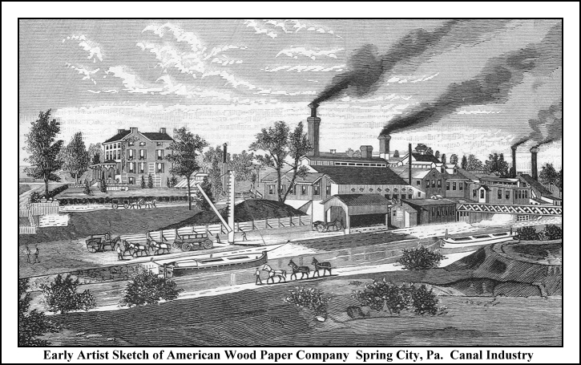
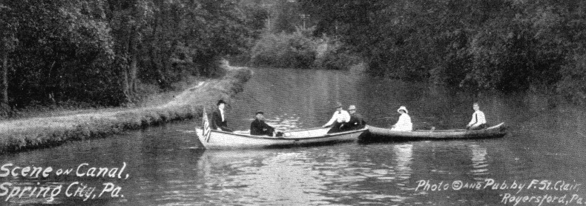
The canal was enlarged and improvements made in the early years and by the 1850’s there was 5 million tons of coal being shipped annually. It was during this time that the railroads started to have a major impact on the transportation markets. The canal business peaked in the 1870’s. Rail shipping was faster, cheaper and operated all year long. The canal could not compete and eventually was leased to the Philadelphia & Reading Railroad. Although the canal had become obsolete for commercial use it continued to operate until the 1920’s. The section of the canal that came through Spring City continued to be used in the summer for boating and fishing and in the winter for ice-skating.

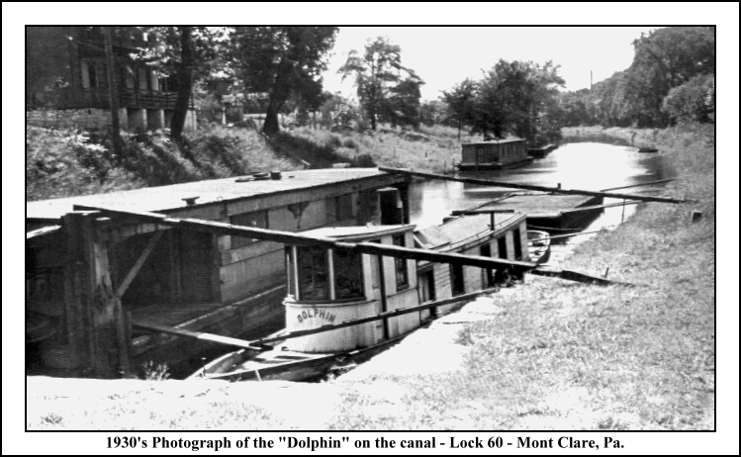
In the 1940’s the remainder of the canal in Spring City was filled in, as the stagnant waters had become a breeding grounds for mosquitoes. People in this area who are interested in learning more about the canal are extremely lucky since a small section of the canal still remains. Lock 60 and the lock keeper’s house along with a 2-½ mile stretch of the canal from Mont Clare to Port Providence are currently being cared for and restored under the watch of the Schuylkill Canal Association. This section is on the Montgomery County side of the river just across from Phoenixville and a short trip indeed for any local canal fan. For more information please refer to their website at www.schuylkillcanal.com
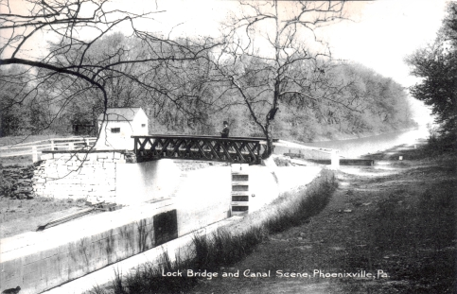
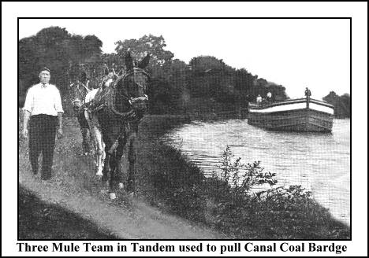
by William C. Brunner

Spring-Ford Area Historical Society Newsletter Insert for January 2005

